**Variables**

**1. Creating multiple requests which has same URL**

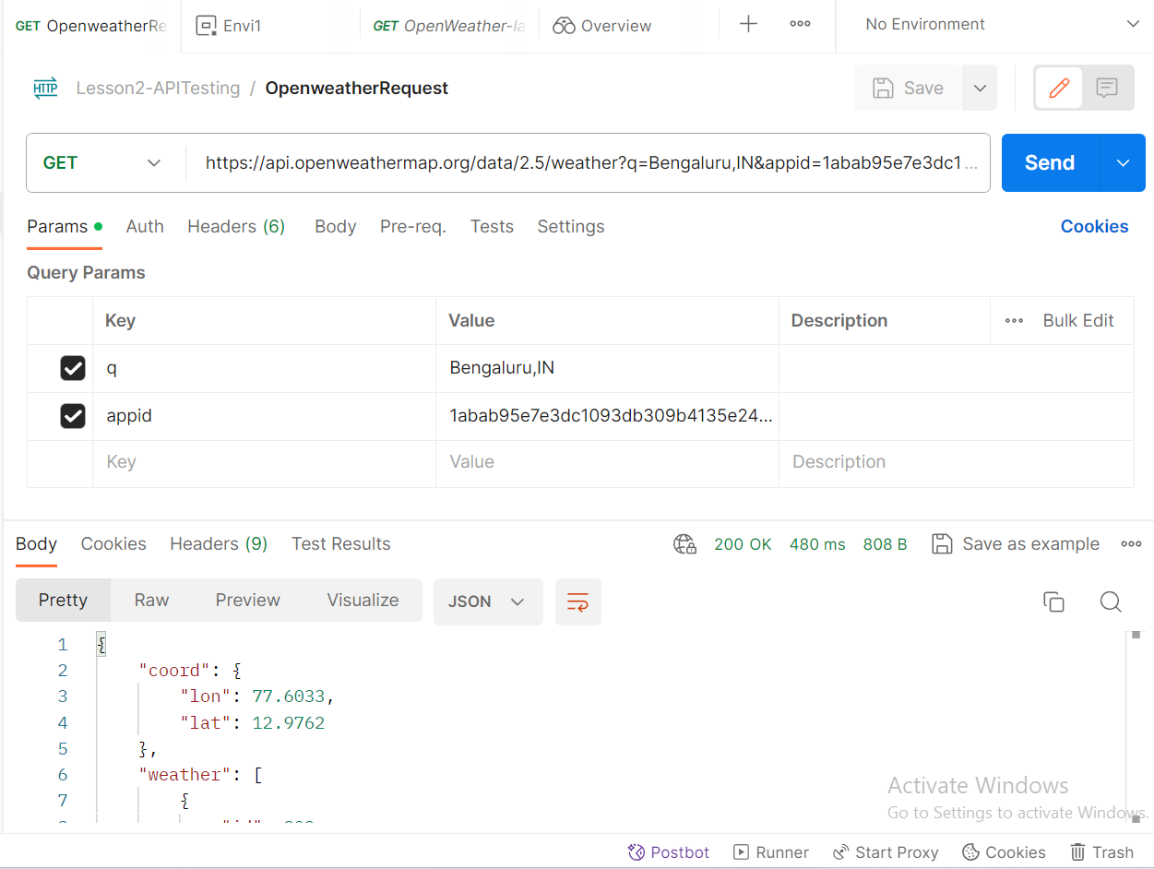

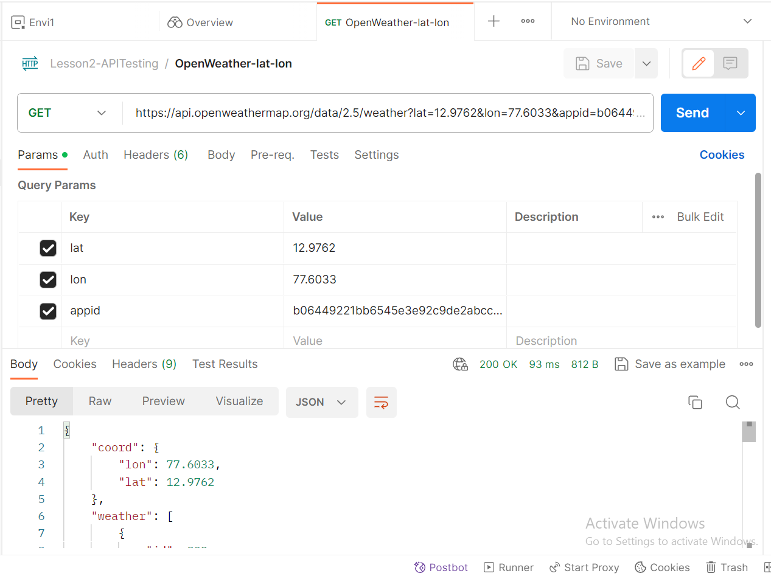

**2. Create an environment and a variable in it**

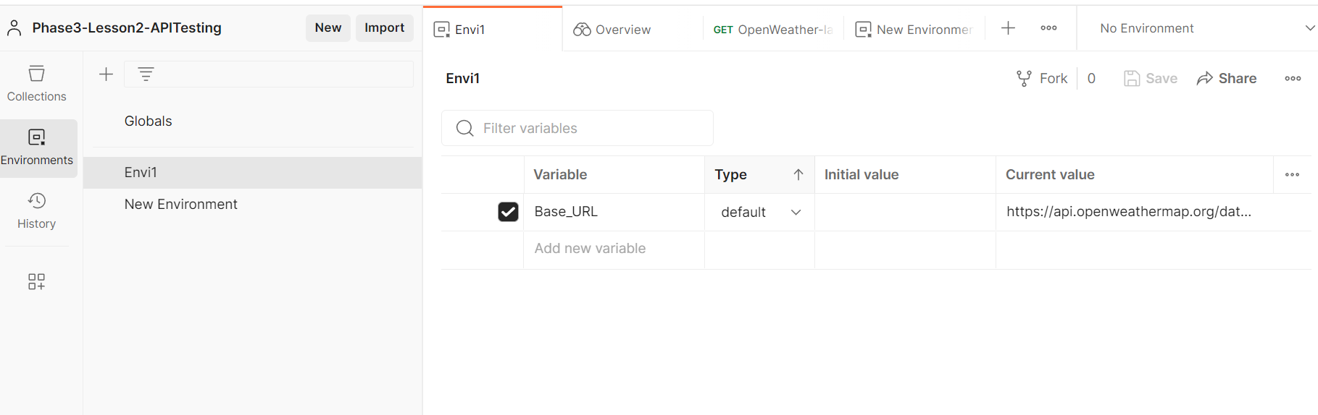

**3. Select the created environment name in request dropdown**

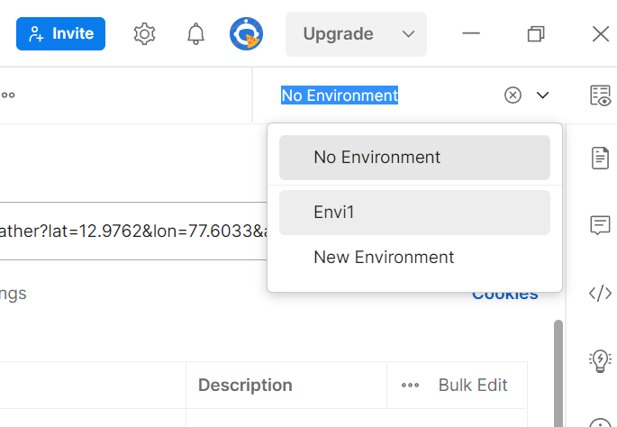

**4. Replace the path with variable**

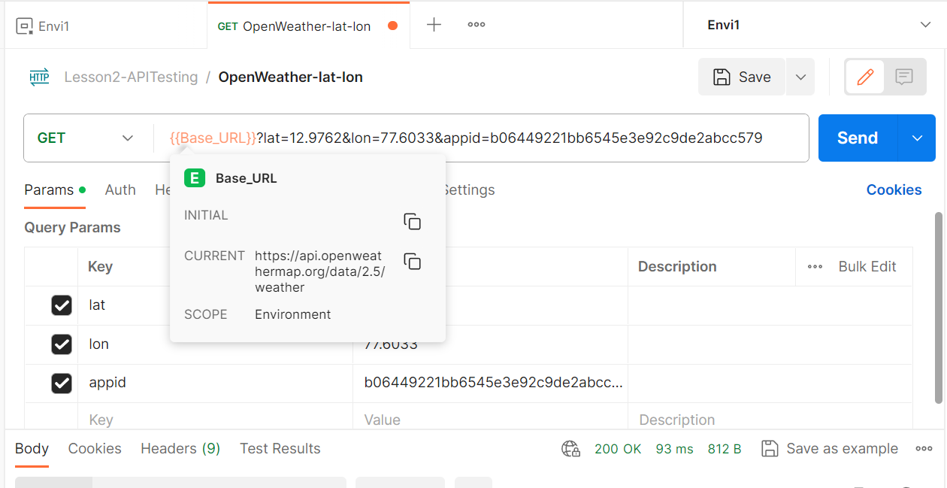

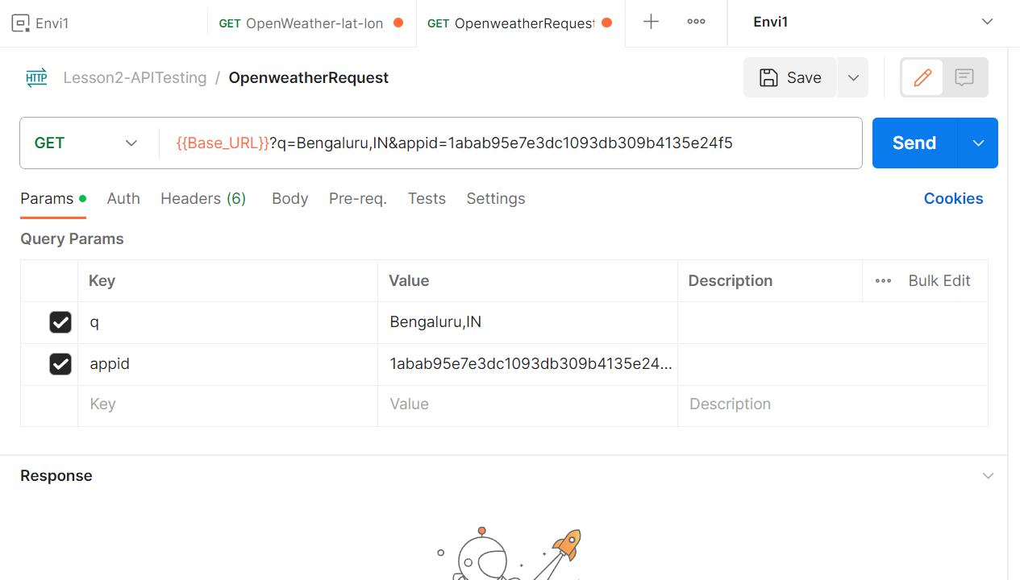

**5. Save and send, observe response**

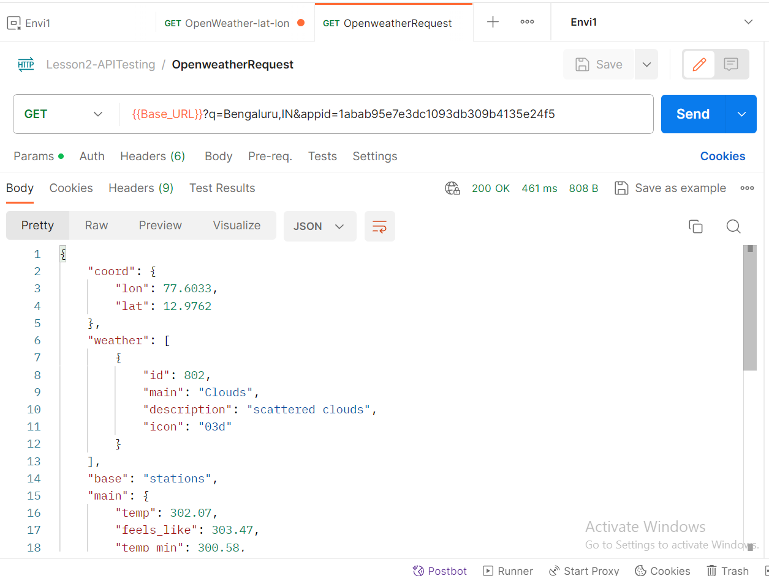

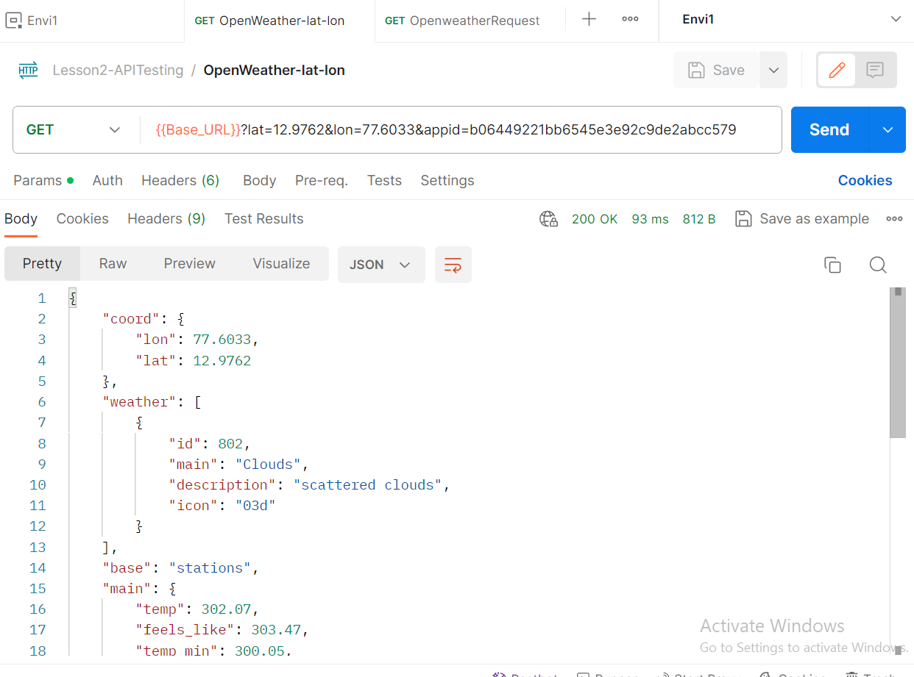

**6. Using local value in pre request scripts**

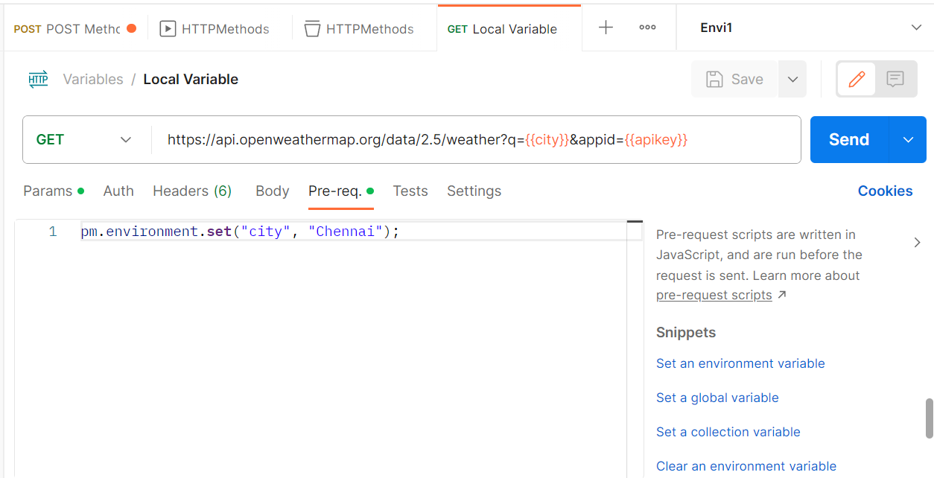

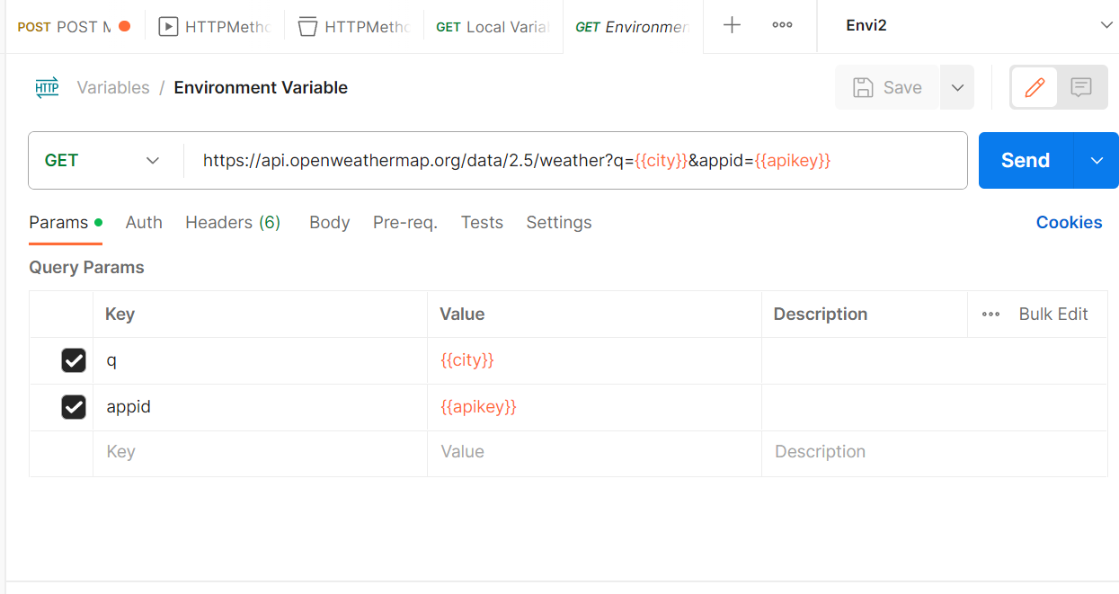

**7. To create collection variable**

**Click on collection name on dashboard**

**Click on variables**

**Provide variable name and its value**

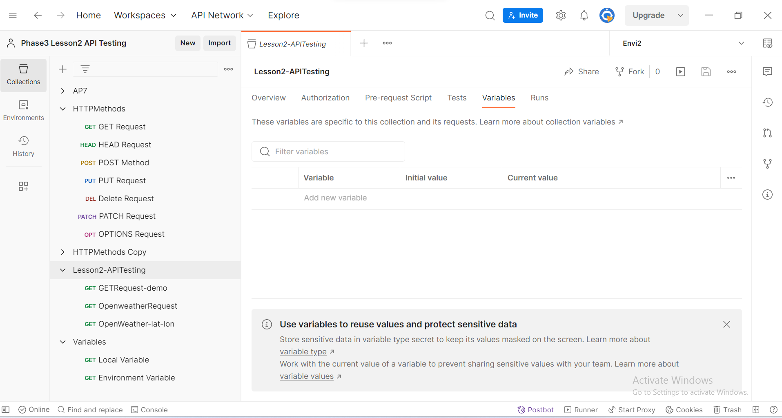

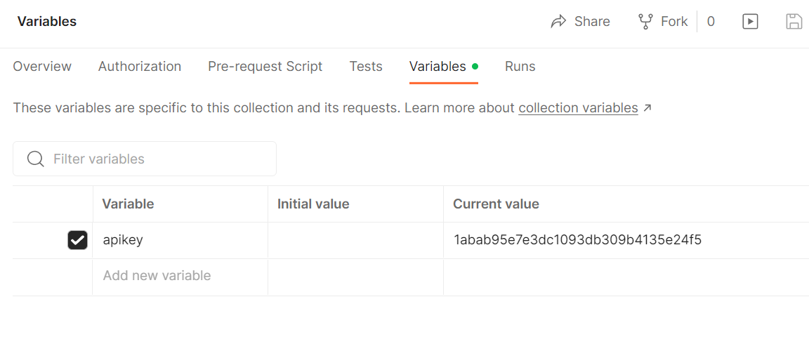

**8. To Create global variable, click on Globals on Environments section**

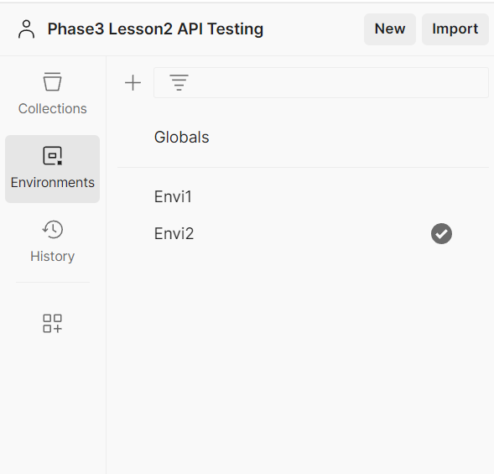

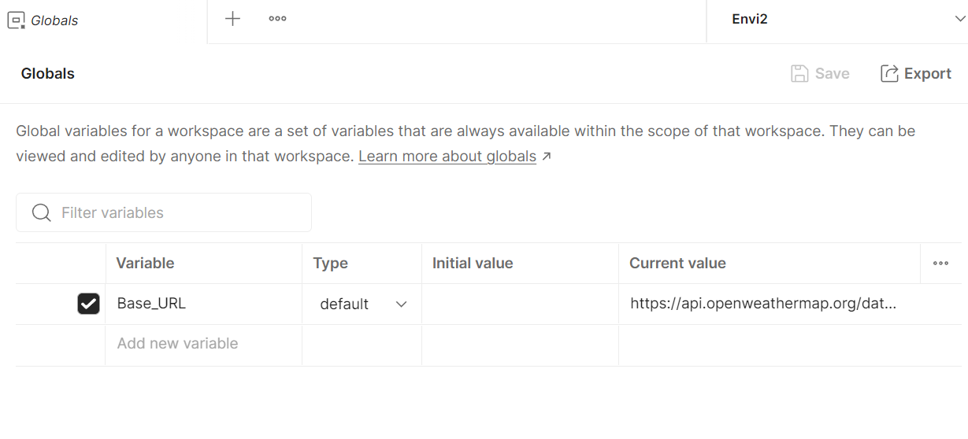

**9. If no environment selected in request, global variable is considered**

